Show Jumping League 1  The Fife Riding Club Showground – Glenrothes  Wednesday 8 May 2024 | 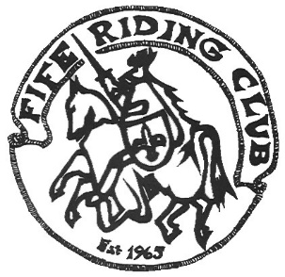
Entries via clubentries.com unless by arrangement with organiser. Entries close Monday 6 May.

Class | Section | League Restrictions
Class 1 | Beginners | Maximum height 45cm.  For nervous/inexperienced horses/riders
Class 2 | Minimus | Height 50-55cm.  No horse and rider combination to have been placed 1st to 3rd at Nursery Novice level on more than 3 occasions.
Class 3 | Nursery Novice | Height 60-65cm.  No horse and rider combination to have been placed 1st to 3rd at Novice level on more than 3 occasions.
Class 4 | Novice | Height 70-75cm.  No horse and rider combination to have been placed 1st to 3rd at Intermediate level on more than 3 occasions.
Class 5 | Intermediate | Height 80-85cm.  No horse and rider combination to have been placed 1st to 3rd at Open level on more than 3 occasions.
Class 6 | Open | Height 90-100cm

Class 1 will start at 7pm sharp unless otherwise indicated. Please ensure you arrive in adequate time to walk the course and be warmed up ready to jump at the stated time.

The show jumping league is intended to encourage riders and horses to progress through the levels year on year, therefore riders will remain in their nominated league throughout the four league competitions.

Riders are eligible to enter any two classes, their nominated league class and the class directly above or below. Horse and rider combinations will only accrue points for their nominated league class. The “extra”, non-nominated class must be HC. If the classes are over-subscribed the organiser reserves the right to ballot out any non-designated class entries.

**Please remember to state your nominated league class when placing entry

