GLENBRAE RIDING CLUB WOULD LIKE TO THANK THE FOLLOWING SPONSORS:

Daniel Scott Eventing
Daniel is a professional eventer based in Stirlingshire and a regular competitor at Burgie.
Daniel is a member of the Horse Scotland Development Squad and has been part of the Performance squad for the past 5 years. Daniel is qualified to UKCC Level 2 Eventing and working towards Level 3.
Daniel won his first Young Rider Trials when he was 17 and two years later won the Hopetoun CIC2* competition as well as the Young Rider Trials at Lincoln. He repeated his Lincoln victory in 2013 when he was shortlisted for the UK Young Riders Team. In 2012, he was awarded the Top Spec Eventing Scholarship. He started competing at senior level in 2014 and since then has a consistent level of top 10 placings with his eight rides spread across the levels from BE100 to Advanced.
Daniel trains closely with Erik McKechnie, John Ledingham, John White and Ruth Edge.
Daniel is looking to expand on his teaching skills and is keen to train people of all levels and abilities to help them progress and develop to reach their maximum potential. He has helped nervous novice riders’ progress to become confident to have fun and enjoy their horses along with working with more established partnerships to achieve their competing goals.
Daniel Scott 07909865438

Dunmore Dog Walking Services.
Dunmore Dog Walking Services offers dog walking for all circumstances & has a variety of walking options & service plans. I aim to provide a high quality service while giving your dog the time & space to enjoy themselves. I am canine first aid trained & a member of the National Association of Pet Sitters & Dog Walkers (NARPS). No matter what your situation is I'm happy to help & make sure your pet fully catered for.
www.dunmoredogwalkingservices.co.uk or enquiries@dunmoredogwalkingservices.co.uk 07985291648

Central Equine Vets.
Central Equine Veterinary Services Ltd is a first opinion, ambulatory (mobile) equine veterinary practice based in Edinburgh. The clinic provides a high quality service to horse, pony and donkey owners in the Edinburgh, Mid, West and East Lothian, Falkirk, Dunfermline, Kirkcaldy and Clackmannanshire regions of central Scotland.
Contact: 0131 6645606 or 01577863333

Redlands livery Yard.
Small quiet friendly yard with direct access to forestry hacking. All year turnout, recently resurfaced floodlit arena with jumps. The yard is centrally located.
If you would like more information please email Astell. Red1lands@aol.com

Munro’s Mutts.
Munro's Mutts dog walking and pet services available in Denny, Bonnybridge, Falkirk and surrounding areas. We offer a full range of services from dog walking, pet sitting and 24hour emergency pet taxi service. Fully insured, disclosure Scotland checked, hold an up to date canine first aid certificate, experienced, knowledgeable and reliable. Please get in touch to discuss your pets needs call Kayleigh on 07979146507.

Heather Macgowan

D40 Enterprises incorporating D40 Agricultural Services, services include residential letting and management services, internal and external works, land management and maintenance.
Contact d40enterprises@icloud.com

Blairs Farm Livery
We offer DIY livery near Torwood, fantastic facilities include, 48x55m bright indoor arena with full set of Showjumps, a second large outdoor sand/rubber school and a third outdoor arena with rustic/Xc jumps.
Indoor arena is available to hire (with or without jumps) for non liveries £30/hour.
Regular clinics and clear round jumping nights are also held, open to all, please follow Blairs Farm Horses page on Facebook.
Please contact Linda stornach for any livery/arena hire queries on 07588 574370
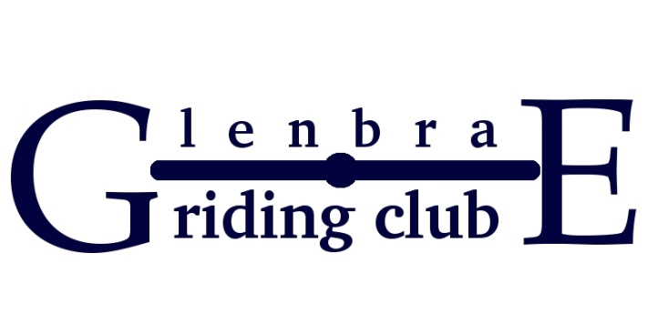

Class 1: Intro C (2016)
Kindly sponsored by: Central Equine Vets

Class 2: Prelim 13 (2006)
Kindly sponsored by: Dunmore Dog Walking Services.

Class 3: Prelim 7 (2002)
Kindly sponsored by: D40 Enterprises.

Class 4: Novice 24 (2010)
Kindly Sponsored by: Blairs Farm

Class 5: 50cm Show Jumping.
Kindly Sponsored by: Redlands Livery Yard

Class 6: 65cm Show Jumping.
Kindly Sponsored by: Munro’s Mutts.

Class 7: 80cm Show Jumping.
Kindly Sponsored by: Daniel Scott.

Class 8: 95 cm Show Jumping.
Kindly Sponsored by: Heather Macgowan

Class 9: Combined Training 1
Kindly Sponsored by: Glenbrae Riding Club

Class 10: Combined Training 2
Kindly Sponsored by: Glenbrae Riding Club

Class 11: Combined Training 3
Kindly Sponsored by: Glenbrae Riding Club

Class 12: Combined Training 4
Kindly Sponsored by: Glenbrae Riding Club

Glenbrae Riding Club Dressage and Show jumping Show.

Dressage: Cost per Test £15. Classes start at 9am.
Class | DRESSAGE TEST | Owners Name | Riders Name | Horses Name | Total
1 | Intro C (2016)
2 | Prelim 13 (2006)
3 | Prelim 7 (2002)
4 | Novice 24 (2010)

Show jumping: Cost per class is £10 Start: 9.30am
Class | Height | Owners Name | Riders Name | Horses Name | Total
5 | 50cm
6 | 65cm
7 | 80cm
8 | 95cm
Total Entry £:
Combined Training: Free to enter. IF YOU HAVE ENTERED A DRESSAGE TEST AND A SHOWJUMPING CLASS YOU WILL AUTOMATICALLY BE ENTERD FOR THE COMBINED TRAINING CLASSES 9 -12
Riders Contact Details.(Please Print)
Riders Name | Address | Telephone Number | Email Address

Emergency Contact Details:

Postal Entries: Mrs Heather Macgowan,
Cruachan Cottage,
14 The Small Holdings,
Sauchenford West,
Stirling,
Fk7 8FB
Cheques should be made payable to: Glenbrae Riding Club

Email entries: h.macgowan@nhs.net and we will Pay Pal Invoice you.
Dressage times will be emailed to the competitors two days before the show and will be listed on the Glenbrae Riding Club Website.
Entries close on Monday 4TH of September 2017.
Rules and Regulations.
- No cheques will be accepted on day of show –cash entries only
- If the organisers feel that the handler has insufficient control over the animal, the handler will be asked to remove the animal from the showground.
- All animals must be sound
- Riders are responsible for removing horse droppings from around trailer/horsebox in car park area
- Please dispose of all litter in bins or take home
- No Dogs are allowed at Blueridge Equestrian Centre.
- All persons whilst mounted must wear a properly fitted and secured hard hat which conforms to the current standard and they must be dressed in a correct and proper manner.
- The organisers reserve the right to instruct any competitor to leave the field
- If, in the opinion of the organiser, a horse requires veterinary attention, this will be sought with or without the consent of the owner/rider
- No refunds will be given
- The judge’s decision is final
- Objections to be lodged with a £20 deposit which will be returned if the appeal is successful
- CONDUCT: If the conduct of any exhibitor is such as shall, in the opinion of the organiser, be injurious to the character or interest of the show, or shall an exhibitor cause cruelty or unnecessary suffering or neglect of any animal, then the organiser may refuse their entry
- Glenbrae Riding Club or anyone acting on their behalf will not be held responsible for any damage, injury to person, vehicle or horse howsoever caused
- It is recommended that competitors have Third Party Insurance
- Whilst every reasonable effort will be made to accommodate exhibitors showing in more than 1 ring, classes will NOT be held up and exhibitors must choose in which class they will compete in the event of a clash

