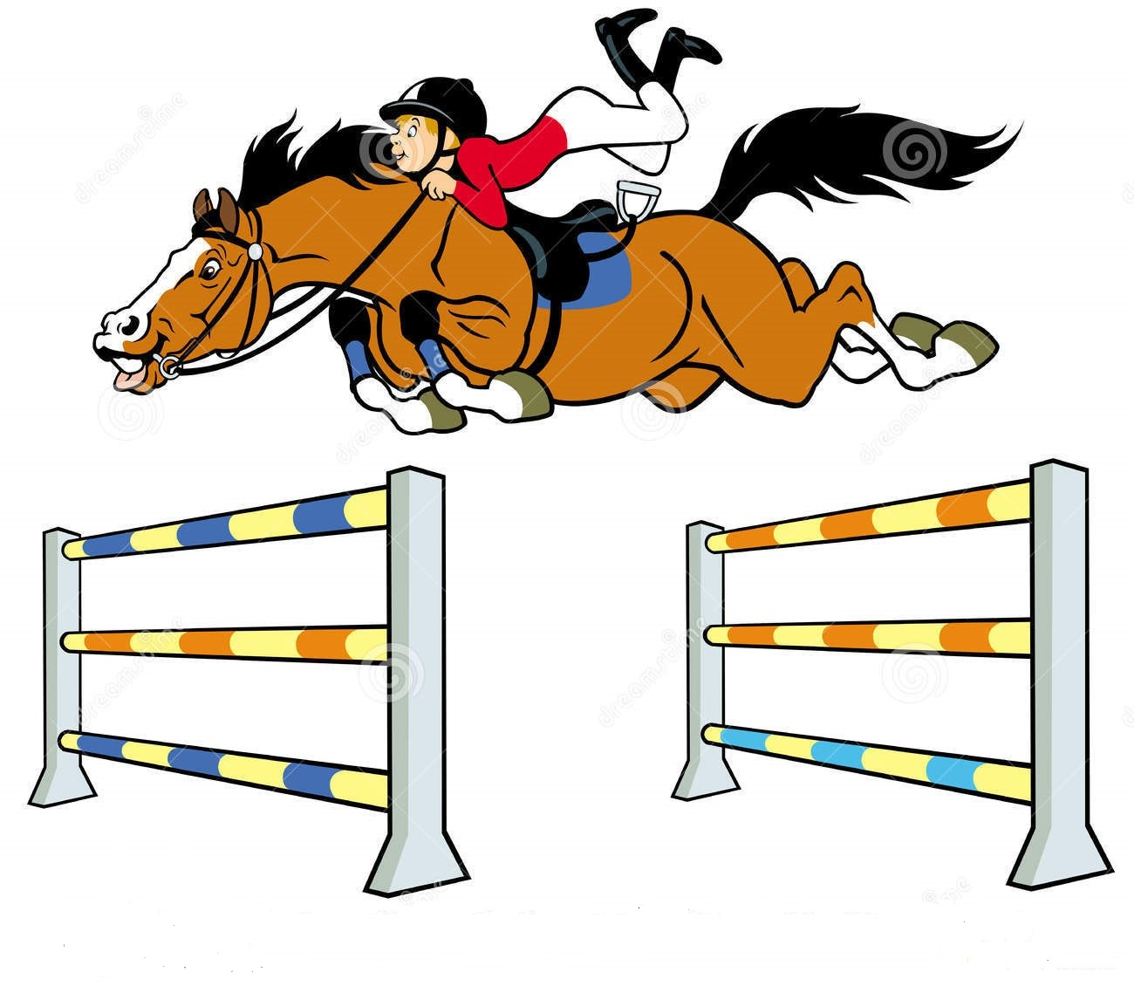
Edinburgh & District Riding Club
Evening Show Jumping Competition

Thursday 27th June 2024
Starts 6.30pm sharp

At Cousland Park Training & Livery Centre, Cousland, Midlothian EH22 2PD
By kind permission of Cousland Park Training & Livery Centre
***Indoor warm-up, all classes ridden on ALL WEATHER SURFACE***

Smart/casual attire, with appropriate safety hat (see rule 6) and riding boots.

Class 1- Intro (A5) Fences 45cm max - Novice rider/horse combinations only - fences will be mixture of cross poles and straight poles designed to encourage people to have a go.

Class 2 – Starter Novice (A5) Fences 55cm max – horse & rider combination not to have won 3 firsts SJ up to 50cm and/or any one class at 60cm or above.

Class 3 – Nursery Novice (A5) Fences 65cm max –horse & rider combination not to have won 3 firsts SJ at 60cm or above.

Class 4 – Novice (A5) Fences 75cm max – horse & rider combination not to have won £50 BS

Class 5 – Intermediate (A5) Fences 85cm max – horse & rider combination not to have won £75 BS

Class 6 – Open (A5) Fences 95cm max – open to any horse/rider combination

Riders that jump clear will be asked to proceed to their jump off round immediately.

**Please note: A second round may be entered in any class as HC. The score from your first round will count towards jump off/placings**

Rosettes to be awarded 1st to 6th for all classes. EDRC members gain league points for relevant placings.

Entries: www.clubentries.com/edinrc

Closing date for entries: Monday 24th June 2024.

Enquiries to: 07810860085

Entry Fees: EDRC Members £14.00 / Non-members £16.00

Online Entries at: http://clubentries.co.uk/edinrc

On the day entries will only be accepted if time allows (not guaranteed) AND the rider has already pre-entered at least one class. On the day entries at an extra £2 per relevant entry fee.

This competition is open to non-riding club members, however is restricted to riders aged 16yrs and over. All riders must hold third party insurance (e.g. BRC, BHS Gold)

Rules
- All horses to be age 4yrs and over and all riders to be aged 16 years or over.
- Horses may not be entered in more than 3 classes (including HC).
- A horse/rider combination entering Class 1 or 2 cannot enter Classes 5 or 6 (and vice versa).
- Strictly no dogs.
- This competition is run under British Riding Club rules 2024.
- Rider must wear ‘Protective headwear’(a hard hat) which meets one of the following standards: PAS 015: 2011 provided they are BSI Kitemarked; or
VG1 01.040: 2014-12 provided they are BSI Kitemarked or Inspec IC marked;
ASTM F1163: 2004a or 04a onwards provided they are SEI marked; 0r
SNELL E2016 (must have official SNELL label and number; or
AS/NZS 3838: 2006 onwards provided they are SAI global marked
- Neither the organisers of this event, nor any person acting on their behalf, the owners of the showground or agents acting on their behalf, accept any liability for any loss, damage, accident, injury or illness to horses, riders, spectators or any other persons or property whatsoever.
- Rosettes to 6th place in all classes.
- EDRC members will receive league table points in all classes (members entering multiple classes will only receive points for placings in the highest level 2 classes (e.g. if entering the 75cm, 85cm and 95cm, only placings in the 85cm and 95cm will count towards league points). Memberships must be fully paid up by closing date of entries to qualify for points. LEAGUE POINTS WILL ONLY COUNT TOWARDS FINAL LEAGUE PLACING IF THE MEMBER HAS HELPED AT AT LEAST 1 EDRC RUN EVENT IN THE CALENDAR YEAR.
- The judge’s decision is final. Any complaints must be made in writing to the secretary within 24 hours of results being published.
- No refunds after entries close, unless the show is cancelled by EDRC. An administration fee may be taken from each competitor.
- Cantering is allowed only in practice and competition areas. Horses must be WALKED into arenas.
- There will be a limited number of entries available in each class.
- The judge’s decision is final. Any complaints must be made in writing to the secretary accompanied by £20 and the complaint must be made within one hour of the incident.
- Horses /ponies should be vaccinated against Equine Flu according to BRC rules.
- ******PLEASE NOTE, use of this venue is subject to certain terms, one of which is that the venue, including the parking area, must be left clean & tidy. As a result, ANY ENTRANTS NOT LEAVING THE PARKING AREAS AS THEY FOUND THEM WILL NOT HAVE FUTURE ENTRIES ACCEPTED. PLEASE THEREFORE ENSURE YOU REMOVE ALL HAY/DROPPINGS/LITTER ETC.

DOUBTFUL WEATHER NUMBER; 07810860085

