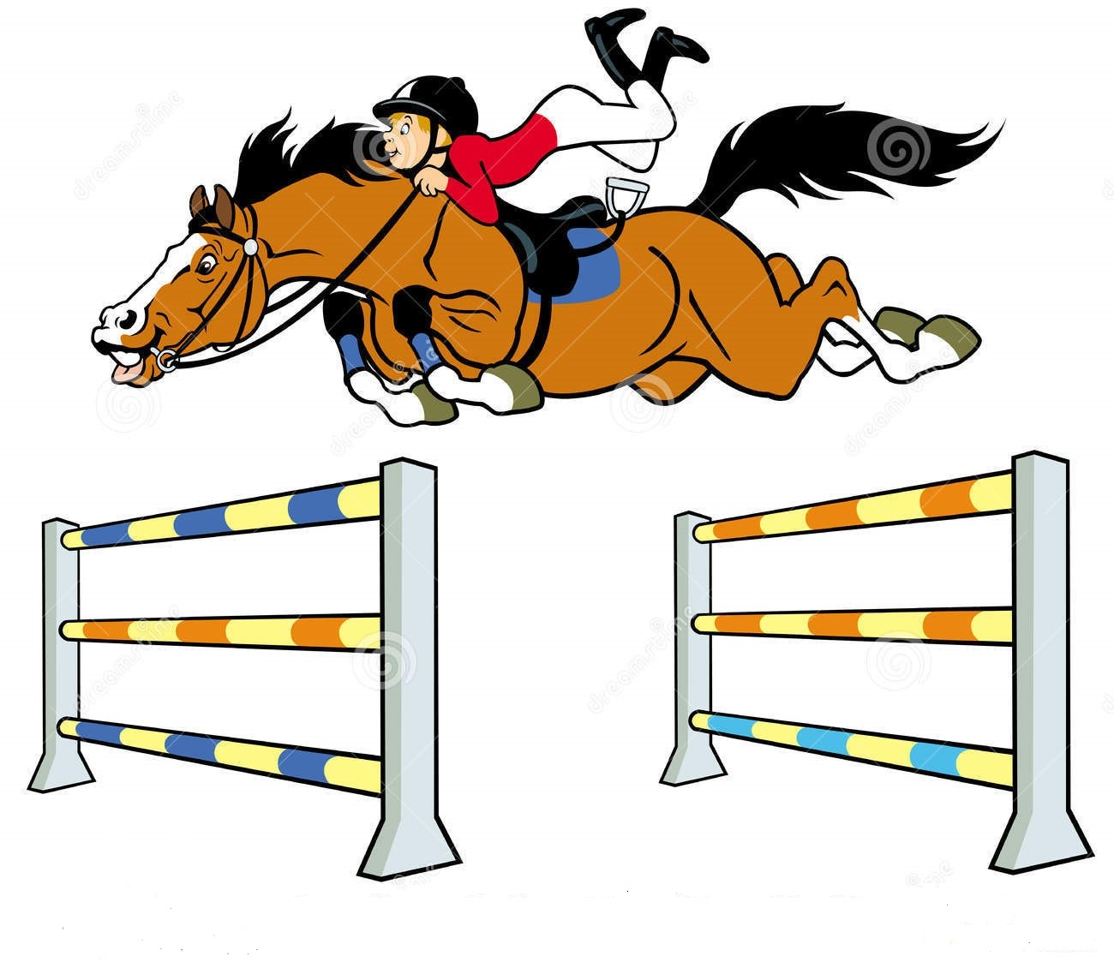
Edinburgh & District
Riding Club
Show Jumping
Competition

Saturday 22nd April 2023

At Cousland Park Training & Livery Centre, Cousland, Midlothian EH22 2PD
By kind permission of Vanessa Ingles
***Indoor warm-up, all classes ridden on ALL WEATHER SURFACE***
Catering will be provided by Angela’s Kitchen - Belter’s Snacks

Competition attire. First class will commence around 10am (dependent on entries).

Class 1- Intro (A5) Fences 40cm max - Novice rider/horse combinations only - fences will be mixture ofcross poles and straight poles designed to encourage people to have a go.

Class 2 – Starter Novice (A5) Fences 50cm max – horse & rider combination not to have won 3 firsts SJ up to 50cm or any one class at 60cm or above.

Class 3 – Nursery Novice (A5) Fences 60cm max – horse & rider combination not to have won 3 firsts SJ at 60cm or above.

Class 4 – Novice (A5) Fences 70cm max – horse & rider combination not to have won £50 BS and/or horse & rider combination not to have won a class at 90cm or above.

Class 5 –Take your own line Fences 70cm – 80cm max – **FUN CLASS** Jump all the fences in anyorder, fastest time wins.

Class 6 – Intermediate (A5) Fences 80cm max – horse & rider combination not to have won £75 BS and/or horse & rider combination not to have won a class at 1m or above.

Class 7 – Small Open (A5)Fences 90cm max – horse & rider combination not to have won £100 BS

Class 8 – Open (A5) Fences 100cm (higher in second round if demand)Open to any horse & rider combination

**Please note: A second round may be entered in any class as HC. The score from your first round will count towards jump off/placings. Please enter using the HC field on club entries and note which class your HC is for.** Horses must not be entered in more than 3 classes (including HC).

Rosettes to be awarded 1st to 6th for all classes. EDRC members gain league points for relevant placings.

Closing date for entries: Wednesday 19thApril2023.
Times will be available Thursday 20th April via Clubentries.

Enquiries to:07980941066.

Entry Fees: EDRC Members £14.00 / Non-members £16.00
A mandatory first aid fee of £3 is required per competitor

Online Entries at:http://clubentries.co.uk/edinrc

On the day entries will only be accepted if time allows (not guaranteed) AND the rider has already pre-entered at least once class.On the day entries at an extra £2 per relevant entry fee.

This competition is open to non-riding club members, however is restricted to riders aged 16yrs and over. All riders must hold third party insurance (e.g. BRC, BHS Gold)

Rules
- All horses to be age 4yrs and over and all riders to be aged 16 years or over.
- Horses may not be entered in more than 3 classes (including HC).
- A horse/rider combination entering Class 1, 2 or 3 cannot enter Classes 7 or 8 (and vice versa).
- Strictly no dogs.
- This competition is run under British Riding Club rules 2023.
- Rider must wear ‘Protective headwear’(a hard hat) which meets one of the following standards: PAS 015: 2011 provided they are BSI Kitemarked; or
VG1 01.040: 2014-12 provided they are BSI Kitemarked or Inspec IC marked;
ASTM F1163: 2004a or 04a onwards provided they are SEI marked; 0r
SNELL E2016 (must have official SNELL label and number; or
AS/NZS 3838: 2006 onwards provided they are SAI global marked
*From 1 January 2023 the PAS 015: 1998 and SNELL E2001 are no longer accepted
- Neither the organisers of this event, nor any person acting on their behalf, the owners of the showground or agents acting on their behalf, accept any liability for any loss, damage, accident, injury or illness to horses, riders, spectators or any other persons or property whatsoever.
- Rosettes to 6th place in all classes.
- EDRC members will receive league table points in all classes (members entering multiple classes will only receive points for placings in the highest level 2 classes (e.g. if entering the 70cm, 80cm and 90cm, only placings in the 80cm and 90cm will count towards league points).Memberships must be fully paid up by closing date of entries to qualify for points.
- The judge’s decision is final. Any complaints must be made in writing to the secretary within 24 hours of results being published.
- No refunds after entries close, unless the show is cancelled by EDRC. An administration fee may be taken from each competitor.
- Cantering is allowed only in practice and competition areas.
- There will be a limited number of entries available in each class.
- The judge’s decision is final. Any complaints must be made in writing to the secretary accompanied by £20 and the complaint must be made within one hour of the incident.
- Horses /ponies should be vaccinated against Equine Flu according to BRC rules.
- ******PLEASE NOTE, use of this venue is subject to certain terms, one of which is that the venue, including the parking area, must be left clean & tidy. As a result, ANY ENTRANTS NOT LEAVING THE PARKING AREAS AS THEY FOUND THEM WILL NOT HAVE FUTURE ENTRIES ACCEPTED. PLEASE THEREFORE ENSURE YOU REMOVE ALL HAY/DROPPINGS/LITTER ETC.

DOUBTFUL WEATHER NUMBER; 07980941066.

