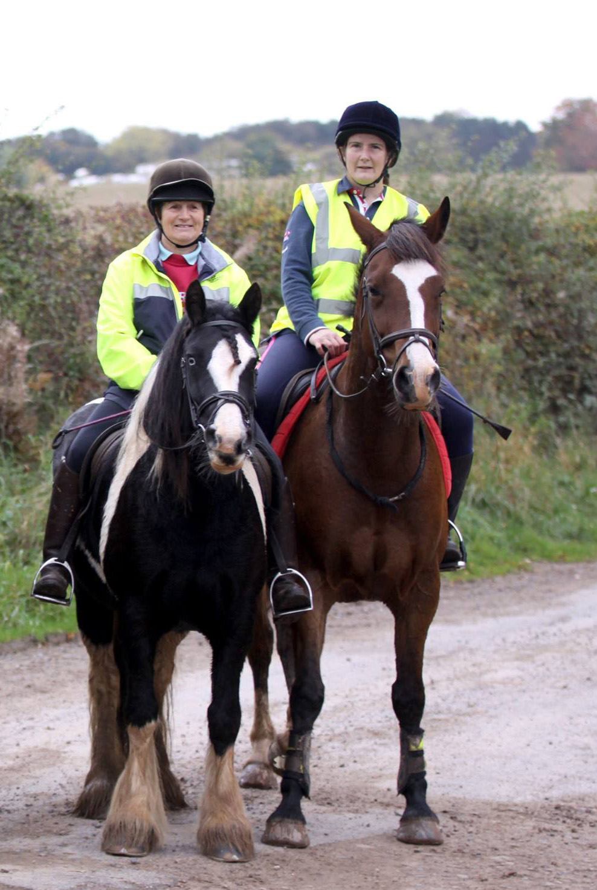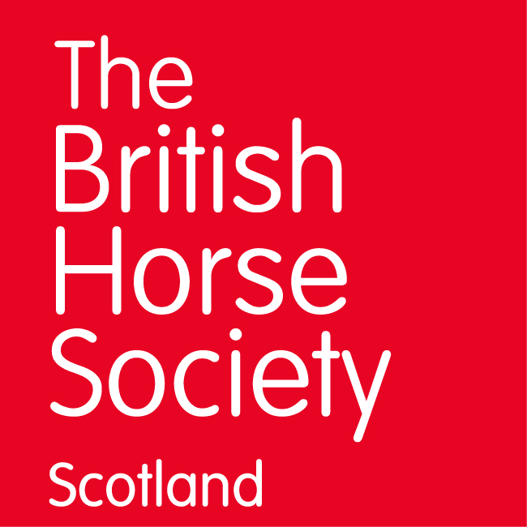

Charity Pleasure Ride

BHS Borders

Come and support our fundraising ride through our beautiful Border countryside. Options to ride either 8 or approx 12 miles in two loops at your own pace. Varied terrain, fields, forestry, a section of quiet roadwork and few gates. Home baking available.

For further information, please contact:

Entry is £15 per horse. Book online at <https://clubentries.com/bhsborders/>

Under 16s must be accompanied by an adult.

Funds raised will be split between the Brooke and BHS Borders Access fund. Please bring horse passports with up to date flu vaccination.

BHS Borders Facebook

BHS Event Organiser: Lesley Muirden 07587 254702 lesleymuirden@tiscali.co.uk

**Sunday 5 May 2019 from 10am, with last ride leaving 12pm**

ion/address here)

The British Horse Society is a Registered Charity Nos. 210504 and SC038516

