Mr Peter Andrew Shaw –
- Dip Teach General Primary
- NCAS Level 3 Dressage Special and coach educator
- National A Level “Grand Prix” Dressage Judge
- Dressage judge educator
- FEI Level 3 Event Judge
- FEI listed Dressage specialist judge educator.

Peter started his riding life at eleven years old, riding bareback around the streets of Newcastle, New South Wales, of a Saturday afternoon. His passion began after seeing horses going past the family home, in the city. Peter convinced his parents to increase his 20c a week pocket money to 50c a week, so he could pay for his riding each Saturday afternoon. A year later he attended a riding camp and was introduced to a saddle and some great training. From his first ride bareback around the streets of Newcastle, this was the beginning of a devotion and obsession, even though he didn’t ride in a saddle again for another year, lasting to this day and not waning at all, though times could be tough. So, after 50 years of riding, learning and loving horses, and 46 years of coaching and judging Peter is now reaping the rewards of his dedication as a judge and a coach.

Peter competed successfully in Dressage, Jumping, Eventing, Showing and sporting. His background is not that of a typical horse person, being from a family who isn’t horsey at all, with limited funds and support, but as they say, a smooth sea never made a skilled sailor. So, tenacity, strength of character, honesty and compassion were the traits Peter found he had embedded into his being and functioning in the horse world, plus a care for the underdog and the horses themselves. These skills and qualities along with his abilities, have underpinned his longevity in the sport. Peter has ridden successfully to FEI dressage, produced riders to from Preliminary to Grand Prix. He has also trained and worked with many eventers and even from a young age where he trained the winner of Gawler 3DE in 1983, who went on to represent Australia at the World Championships in Gawler, 1986, and many other winners and places getters from beginners to medallist internationally. He is an accredited Level 3 Dressage specialist with the Australian National Scheme and is one of the few instructors able to coach all types of horses for all sorts of disciplines with his sensitive and knowing approach to each horse and rider as an individual.

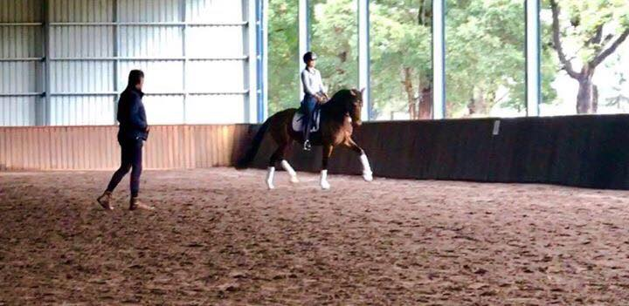
Parallel to all his riding and coaching, after finishing high school, Peter qualified as a Primary School teacher and a whole other chapter of his life began. This chapter often ran parallel with his riding and coaching, but also took a back seat at times, as Peter was promoted repeatedly till he was selected as Principal of three schools in New South Wales, taking each of these schools to become the “Jewel’s in the Crown,” for their districts. His focus on building a shared value system, inclusive culture for all stakeholders, and providing educationally rich and quality, diverse experiences for children, teachers, parents and their communities became his focus and thousands have benefited from his passion and commitment to education, children, families and people.

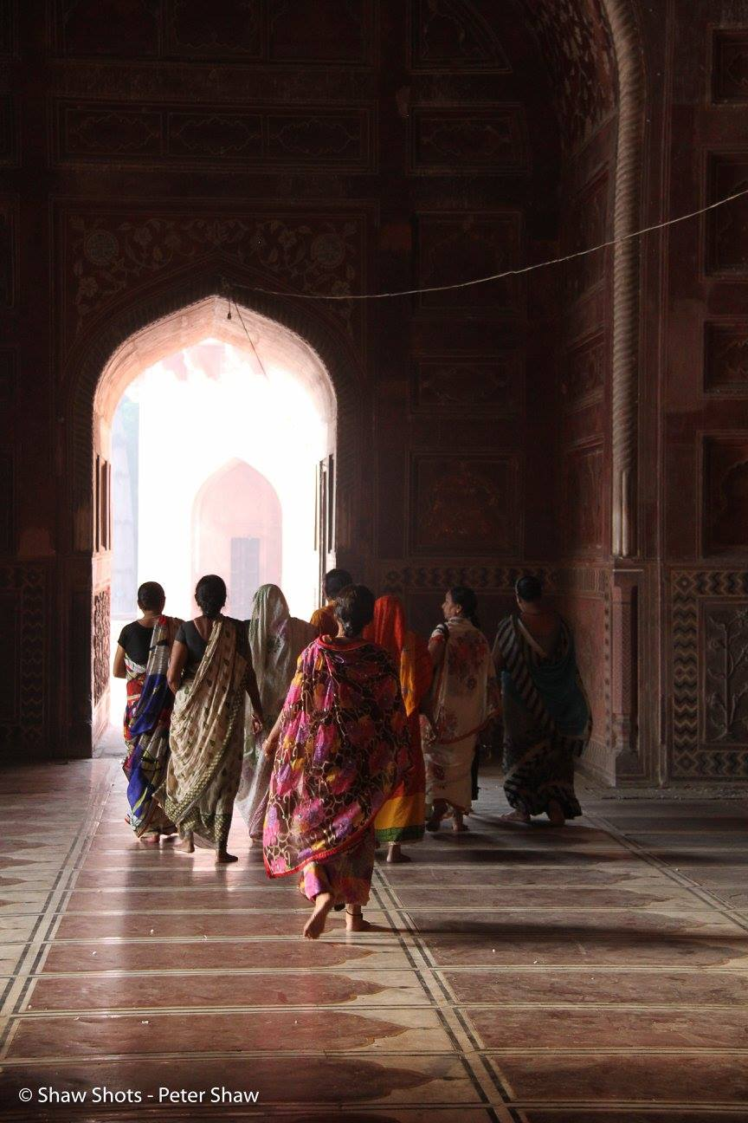
At 16 Peter commenced judging and started the Hunter Valley Dressage Association at 17, a club that became to first club to host the state championships outside the Sydney Metropolitan area. In 1988 Peter achieved his qualifications as a Grand Prix judge, making him the youngest GP Judge in the world at the time and judge in the world at the time and one of the most long-standing judges in Australia, still active in the sport. To add to this, he is now also, an FEI Level 3 judge, formally known as FEI 3/4**** judge having judged in many country already. This year Peter was added to the FEI list of Judge Educators as a dressage specialist.

Peter developed a passion for photography in the last ten years and often combines his passions of horses, people and photography for his and many other people’s education and pleasure. Peter is one of those rare people, who remains real, relevant, passionate and hopefully in a world of quick fixes and instant gratification practises. Even though from Australia, not the mecca of dressage etc, he looks to the best in the world for his inspiration and his standards, judging and instruction reflect that strive for the best.

