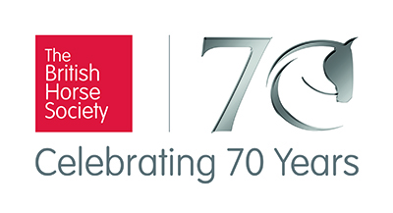
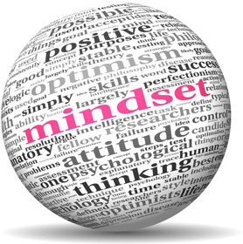

Sports Psychology Workshop - Mindset for Riders

At the Olympics Steve Redgrave said that 90% of performance on the day is due to Mindset.

Whether we are leisure or competition riders we know that our mindset affects both us AND our horses - so how do we get it right? This can also be a challenge for our Coaches and Trainers.

On Thursday 1st March 2018 from 10am to 2.30pm at Auchterarder Golf Club, BHS Scotland is running a workshop session with Katie Sinnott, an experienced Sports Psychologist. This will be a practical and enjoyable session with exercises such as, looking at the 'controllables' within one's (equestrian) life and how the use of a technique called 'thought-stopping' can change negative self-talk into positive self-talk.

Katie has over 10 years experience providing psychological support to individual athletes, squads, coaches and officials of varying ages and standards, from amateur/club level up to, and including, World, Commonwealth, European and Paralympic champions and across 39 sports from Archery to Wrestling.

Bookings can be made online at https://clubentries.com/bhsscotland/index.php - please book early as numbers will be restricted.
Cost:
£20 including lunch
Reviews:
“Really made me look at the way I prepare for and think at a competition” - an active BRC and BD member.
“I found her very helpful. It really helped me to focus on the controllables, especially when my boot zip burst as I got on to warm up! Improved focus helped me to warm up effectively and I was happy with our performance. I will continue to use the techniques she showed us.” – an active BRC and BD member.
“Thoroughly enjoyed the evening. Gave me pointers to work on. Give 100% when you ride! Don’t doubt yourself! – a new riding club member who competes at unaffiliated dressage.

