Would you like to start to coach in
The Pony Club?

‘INTRODUCTION TO PONY CLUB COACHING – STEP 1’

Date: Saturday 11th December 2021

Time: 9 30 until 3 45pm

Cost: £46 for current Pony Club members, £56 for all others

Application process
Please pay the relevant fee to secure your place on the course using the link to club entries: https://clubentries.com/deesidepc

Catering: Refreshments are included but please bring a packed lunch

Venue: Mergie, Rickarton, Stonehaven, AB39 3TH

There are 12 places available on this a fun, informative, hands on course. The morning is class room based, with practical coaching sessions in the afternoon. It is a mainly practical course.
PC members who are 16 or over and hold at least C Test are welcome, along with anyone who is interested in learning more about coaching in The Pony Club

Look below and on www.pcuk.org for more information. The links to the PC website are for PC Efficiency Tests, Progressive Awards, Achievement and Sports Badges.
We look forward to seeing you as you start your Coaching journey, or if you want to refresh your ideas.

http://www.pcuk.org/index.php/tests_and_achievements/efficiency_tests/

http://www.pcuk.org/index.php/tests_and_achievements/progressive_tests/

http://www.pcuk.org/index.php/tests_and_achievements/achievement_badges/

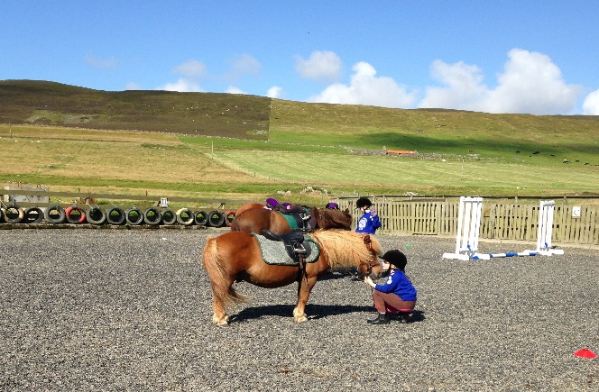

'Introduction To Pony Club Coaching – Step 1'

Who is this course is for?
• Pony Club Members who are 16 – 25yrs (15yr old members may be put forward by their DC/Centre Manager), hold C/C+/B tests and are enthusiastic to teach at D/D+ level (This group will have priority for places)
• Past members/supporters/parents who have sound horse knowledge & are enthusiastic to teach at D/D+ level
• Pony Club Instructors/Coaches at any level who want to refresh their ideas or check they are in line with best practice

What are the aims of the course?
• To help and encourage aspiring Pony Club senior Members to utilise the knowledge they have gained from past Pony Club experience and enable them to start to coach others in a safe, effective and confident way.
• To support and encourage past Members, supporters & instructors to use their enthusiasm, knowledge & experience to start to coach others in a confident, fun, safe & effective way.

What do participants need to wear on the course?
Participants need to be appropriately dressed to teach at a rally and to model a good standard of turn out for Members. The morning is spent in a classroom environment and the afternoon coaching riders. Some people prefer to wear their coaching clothes all day and others prefer to change at lunch time. It is entirely up to you, but clean boots, tidy hair, a riding hat, a plain jacket or PC sweatshirt, minimum jewellery and no hoodies please! The afternoon may be spent either inside or outside dependent on the weather and the facilities available at the venue

How is the course delivered?
This course develops participants through discussion, group work and most importantly, activity. All participants will have the opportunity to teach. The emphasis is on drawing together the wide range of experiences that tutors and participants bring and making those experiences available to everyone. The atmosphere is fun, friendly, welcoming and supportive.

What do participants need to bring?
Participants should bring a Pony Club Manual of Horsemanship, notebook and pen. A copy of the PC Coach Folder would also be helpful and / or copies of the E, D, D+ and C Test efficiency syllabus. Please bring a packed lunch.

Where will participants go from here?
Check out The Pony Club website under 'Training' – www.pcuk.org Coaches can start by assisting experienced Pony Club coaches in Branches & Centres (checking tack, moving jumps/poles etc). Then under supervision and with a mentor, start to assist with coaching members. Attending PC Step 2 and 3 courses, and UKCC Level 1 and 2 courses are the next steps. The Introduction to PC Coaching Step 1 course is the first step towards achieving the Pony Club Steps Certificate.

Do participants gain a qualification?
Participants receive a combined Attendance Certificate and Feedback Slip from the Course Tutor and their attendance will be recorded on the PC database.

