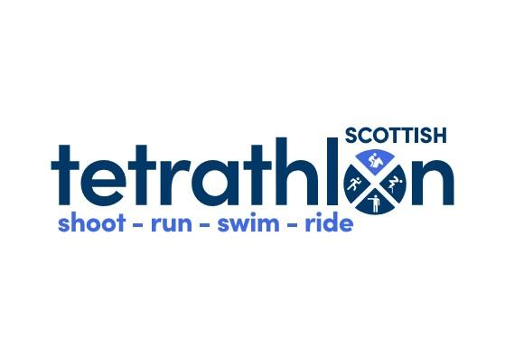
FUN ARENA TETRATHLON KILGRASTON SCHOOL
SUNDAY 7th APRIL 2024
Kilgraston School, Bridge of Earn, Perthshire, PH2 9BQ
Class | PC Age  On 1st Jan 24 * | Shoot | Run | Swim | Ride
1 Junior/Open Boys | 12 & over | 7m  1 hand turning | 1500m | 3mins | 90cm
1a. Junior/Open Boys Triathlon | 12 & over | 7m  1 hand turning | 1500m | 3mins
2. Junior/Open Girls | 12 & over | 7m  1 hand turning | 1500m | 3mins | 90cm
2a Junior/Open Girls Trialthlon | 15 & over | 7m  1 hand turning | 1500m | 3mins
3. Mini Boys | 10-11 yrs | 7m  1 or 2 hand turning | 1000m | 2min | 80cm
3a Mini Boys Triathlon | 10-11yrs | 7m  1 0r 2 hand turning | 1000m | 2min
4 Mini Girls | 10-11 yrs | 7m  1 or 2 hand turning | 1000m | 2min | 80cm
4a Mini Girls Triathlon | 10-11 yrs | 7m  1 or 2 hand turning | 1000m | 2min
5 Tadpole Boys | 8-9 yrs | 7m  2 hands static | 1000m | 2mins | 60cm
5a Tadpole Boys Triathlon | 8-9 yrs | 7m  2 hands static | 1000m | 2mins
6 Tadpole Girls | 8-9yrs | 7m  2 hands static | 1000m | 2mins | 60cm
6a Tadpole Girls | 8-9yrs | 7m  2 hands static | 1000m | 2mins
7 Beanie Boys | 7& under | Bean Bag throw | 500m | 2mins | 40cm
7a Beanie Boys Triathlon | 7& under | Bean Bag throw | 500m | 2mins
8 Beanie Girls | 7& under | Bean Bag throw | 500m | 2mins | 40cm
8a Beanie Girls Triathlon | 7& under | Bean Bag throw | 500m | 2mins
9 Beanies Lead rein | 7& under | Bean Bag throw | 500m | 2mins | 40cm
(*) P.C. Age on 01/01/2024
ENTRY FEE: £40(Triathlon £20/ Beanies Leadrein £30) via clubentries.com/scottishtetrathlon
Any queries please contact katemactaggart@gmail.com
AWARDS There will be individual rosettes to 10th overall place for each class. For each phase in each class there will be 1st place rosettes only. Live scoring for queries (any queries to steward within 30mins of phase ending) and final results will be posted on https://www.ponyclubresults.co.uk/
RULES Competitors must be members of The Pony Club. The competition will be run under 2024 P.C. Tetrathlon Rules. Shooting In accordance with Pony Club rules, those who are under 8 cannot shoot in this competition. Please take note of the clothing rules as we advise you to dress appropriately. Long trousers are strongly recommended. Footwear which does not extend above the ankle must be worn. Protective or prescription glasses are mandatory for shooting at 7 metres and are recommended for all.
ARENA SHOW JUMPING There will not be a slip rail or a gate to negotiate, instead there will be a square to stand in for a set amount of time.

