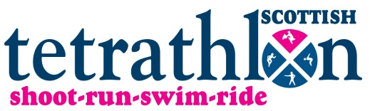 | Indoor Cross Country Training  2022/2023

Scottish Tetrathlon require that all potential 2023 team members attend at least one of the winter indoor sessions. Lessons will be in groups of 3-5 riders to cover the range of Tetrathlon class heights; Beanies 40cm, Tadpoles 60cm, Mini 80cm, Junior 90cm, Intermediate/Open 100cm+.

This training is primarily aimed at those who compete regularly at Tetrathlon and is subsidised by Scottish Tetrathlon. However places are open to all Pony Club members looking to improve their XC.
*Scottish Tetrathletes (competed in 2022 for Scottish Tetrathlon or entered Winter Triathlon Series 22/23) £30 *
Other PC members £35*
Times will be posted on the Scottish Tetrathlon Facebook page from 5 days before the event.

Entries on https://clubentries.com/scottishtetrathlon
Any queries to Sally Barr sally77barr@gmail.com
Aberdeen queries to Ginny Finch ginnyspeight@hotmail.com

Refunds will only be given after the closing date if the space is filled or the lesson is cancelled.
We do try and accommodate requests for certain times of day and groups but, due to the many sibling groups and long journeys for some, this is not always possible.

