**SARC Horse and Dog Christmas Show 12th December 2021**

**At Mill of Uras, Catterline, Stonehaven**

**All classes will have times published after closing date 5th December 2021**

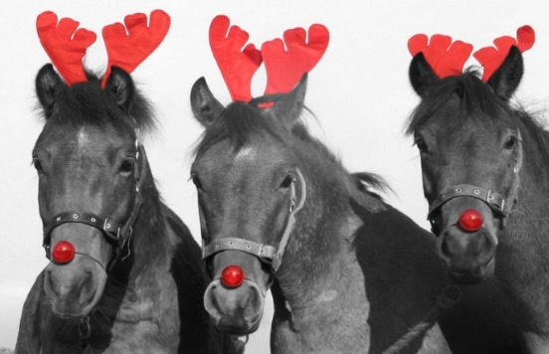**All entries through club entries**

**In-Hand Classes - £8 per class**

Class 1 – Youngstock ( up to 4 yrs no entire males)

Class 2 - Mountain and Moorland (any height and any age, full and part bred)

Class 3 – Veteran (pre 15-19 and 19 plus sections will be spilt if numbers allow)

Class 4 – Hunter/Hack (if numbers permit class will be spilt small and large hunter, and Hack)

Class 5 – Riding club ponies (14’2hh and under)

Class 6 – Coloureds (any height or breed, class may be split into native and non-native sections is numbers allow)

Class 7 – Riding club horses (over 14’2hh)

Class 8 – Horse and pony Santa wishes to take home ideally in fancy dress.

Class 9 – Junior handler (16 years and under class will be split if numbers allow)

**Overall In-Hand Horse and Pony Champion – all 1st placed for all classes to come forward.**

Overall In-Hand Horse Champion Kindly Sponsored by Bogenraith

Overall In-Hand Champion Kindly Sponsored by Barras Blades

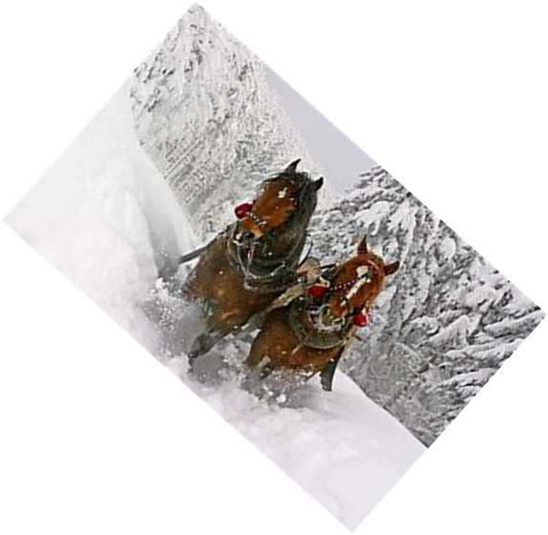

**Ridden Classes - £8 per class**

Class 10 – Lead Rein and Novice Ridden (Class will be split, walk and trot only in the go round, first ridden can canter in their individual show)

Class 11 – Mountain and Moorland (Any height, full and part breds)

Class 12 – Veteran (Pre 15-19 and 19 plus sections will be split if numbers allow)

Class 13 - Hunter/Hack (if numbers permit class will be spilt small and large hunter, and Hack)

Class 14 – Riding Club Ponies (14,2hh and under)

Class 15 – Coloureds (any height or breed, class may be split into native and non-native sections if numbers allow)

Class 16 – Riding Club Horses over (over 14’2hh)

**Horses will not be stripped**

**Overall Ridden champion horse and pony - all 1st placed for all classes to come forward.**

Overall Ridden Horse Champion will be presented with the Callie Cup, Kindly Sponsored by Heather Begg

Overall Ridden Pony Champion Sponsored by the Mill of Uras

[](https://www.bing.com/images/search?view=detailV2&ccid=XcMRt2BD&id=44C5AC59E2189F403157B86729C9E0267CFEDFA5&thid=OIP.XcMRt2BD_TbqLzVfxIOluQHaGM&mediaurl=https://th.bing.com/th/id/R.5dc311b76043fd36ea2f355fc483a5b9?rik%3dpd%2f%2bfCbgySlnuA%26riu%3dhttp%3a%2f%2fwww.qualitycottages.co.uk%2faroundwales%2fwp-content%2fuploads%2f2014%2f12%2fdogs-christmas-costumes-large-msg-135533997133.jpg%26ehk%3dnWmFWamMCcMPs12eHvB7v%2fEYtIRefBbe4Pxz2GPhP%2fs%3d%26risl%3d%26pid%3dImgRaw%26r%3d0%26sres%3d1%26sresct%3d1%26srh%3d799%26srw%3d957&exph=463&expw=554&q=pictures+of+christmas+dogs&simid=608024716240125331&FORM=IRPRST&ck=2F34DE0121D0BCB00C7409CD257C7295&selectedIndex=53)

**Dog Classes - £5 per class (any breed unless stated)**

**Will be held indoors at the Canine Country Club**

Class 17 – Puppy Class (under 1 year old)

Class 18 – Dog in best condition

Class 19 – Most appealing eyes

Class 20 – Dog the judge would like to take home

Class 21 – General working dog (i.e sheep dog, gun dog and service dog)

Class 22 – Most handsome male

Class 23 – Prettiest female

Class 24 – Veteran (over 12yrs)

Class 25 – Junior handler

**All dogs placed 1st in their classes come forward for Best in Show.**

Champion Dog Kindly Sponsored by the Canine Country Club

**Show Jumping**

With a full packed day, once we have final entries in if we have time left we will run some clear round festive jumping, Christmas Relay and maybe a chase me charlie.

**Catering**

We will have catering on site to keep us all fed and watered throughout the day.